**This document represents The User Guide for this web application.**

**Menu**

The menu contains all the sub pages you will be able to navigate freely by just click in over each option. They will be accessible as a guest user without needing to login on the application page.



Sub Pages:

* Home
* About Us
* Contact Us
* Job Offers
* Login

**Home Page**

It is the default loaded page, there you will be able to start a search for your interest jobs. From this page, once you enter the title of the job in the input you will be sent to the Jobs Offers page.

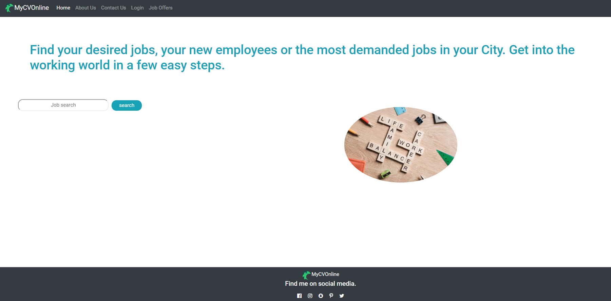

**About Us**

It is a simple information page where you will be able to find the Vision, the Mission, and a small information about this project.

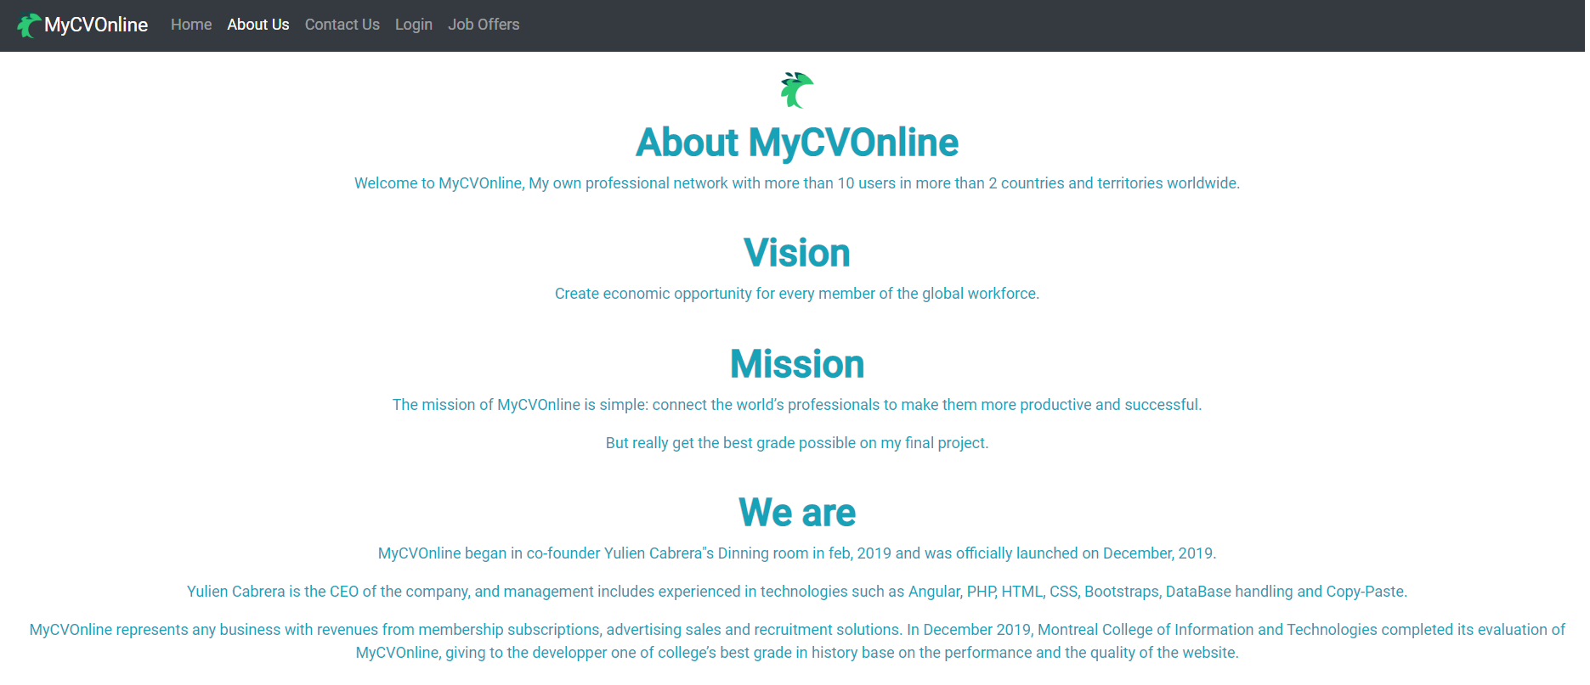

Contact Us

From here you will be able to send us your opinions about the page as well as your suggestions.

You just need to enter your email information, write a note and click on the Send button to reach out for us. (*this feature will come in future updates of the app*).

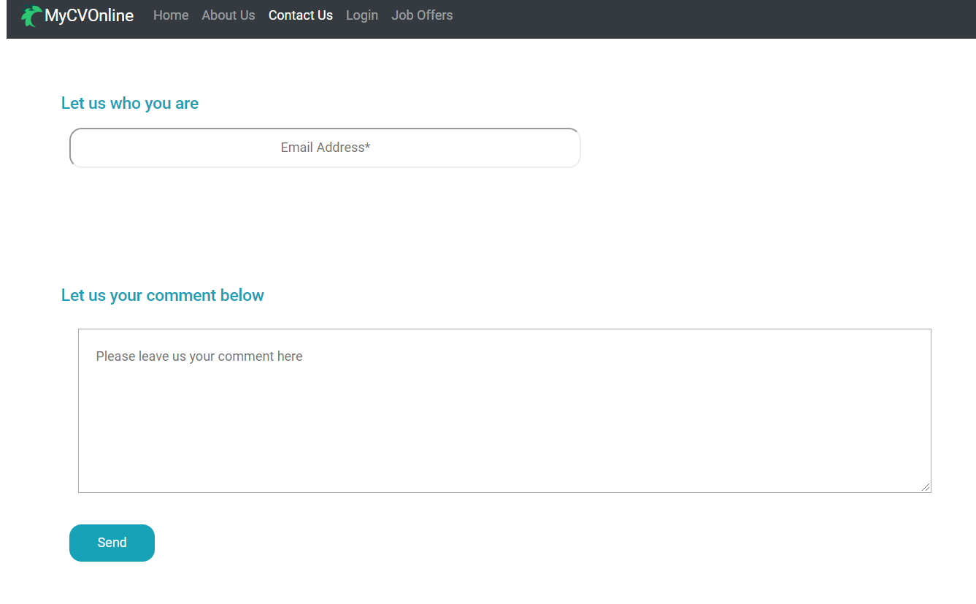

**Login Page**

The Login page will offer you multiple options. You can choose from login as a ***Company*** or***Candidate*** for recurrent users or if there is the case and you are a newcomer you will be able to Sign Up in the system.

***Company****:* Type of user ***Companies*** are allowed to create, delete or modify jobs offers to be posted on the system and saved for candidates to search and apply for it. Also, they will be able to search for Candidates CVs (Resume).

***Candidate****:* Type of user ***Candidates*** can create, delete or modify CVs (Resume) to be posted on the system and save it, to be found by companies.

* **Login**

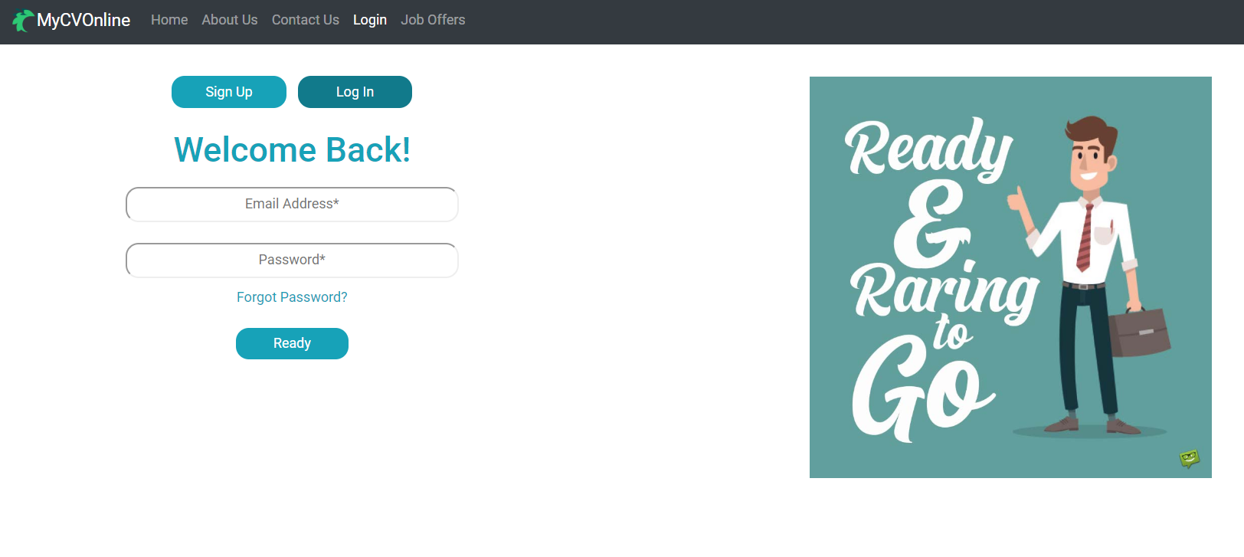

To login you will only require your Email and Password already existent in the system. Both ***Candidates*** and ***Companies*** will use the same method, and they will be sent from here to their respective profile page.

* **Sign Up**

For Signing up you will have to pick the type of User you are (***Candidate or Company***).

***Candidates:*** will be required to enter their First Name, Last Name, Email and Password to be registered in the Database.

***Company:*** will be required to enter the Company Name, Email, Address and Password to be registered in the Database.

Images will show examples below.

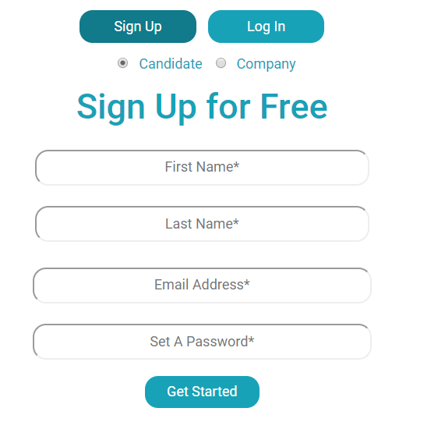 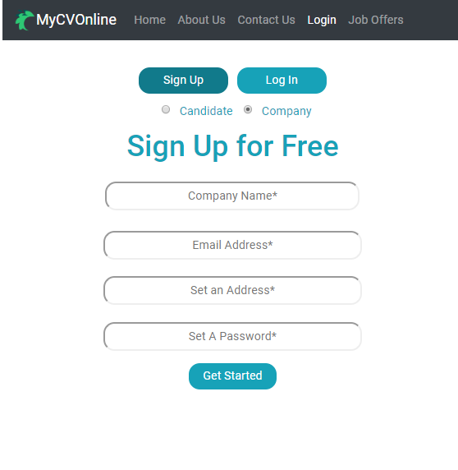

**Candidate Profile**

Once you login as a Candidate you will be able to navigate through the options available for this type of user.

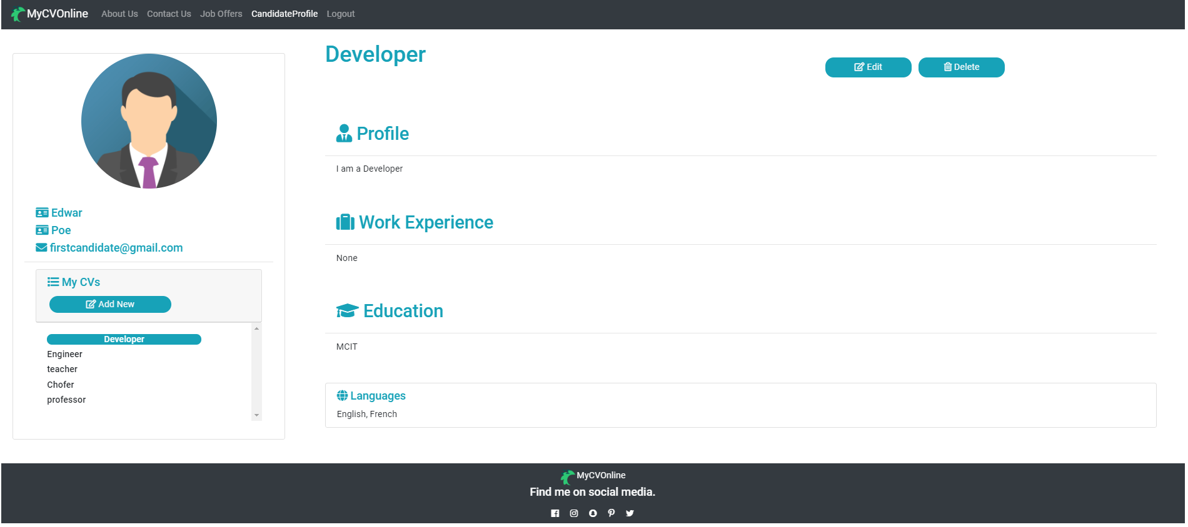

You will be able to create, delete of modify your CVs from this screen. On the left side it will appear your first and last name and email address, under it will appear the list of your created CVs. You can also create a new CV by clicking on the Add New button.

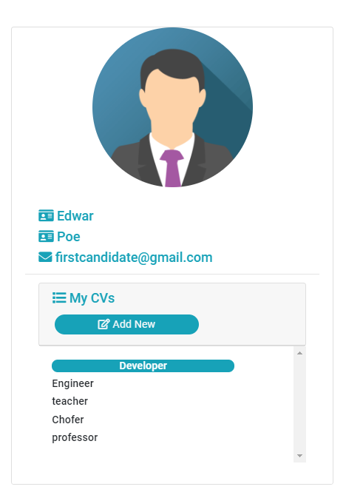

Once you click on the ''Add new’’ button a modal will show up and you will be able to enter the related information to this new CV.

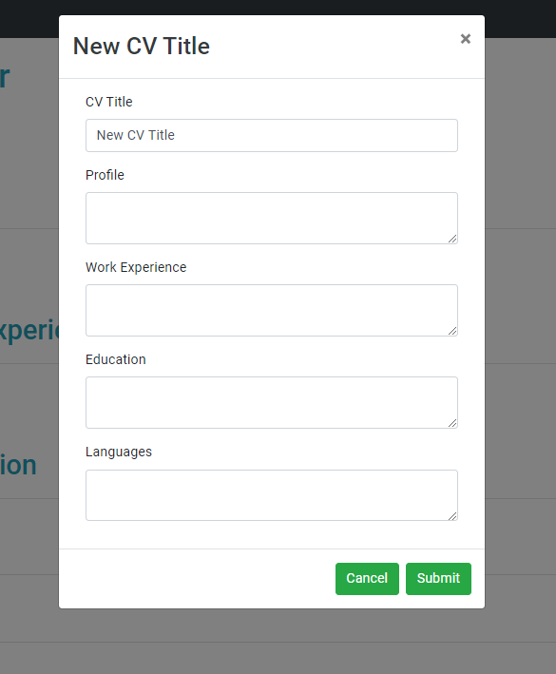

There will be the options to “Submit” that will add the new CV to the list, or to cancel and close the form without adding anything.

On the right side of the screen it will always be reflected the CV you select from your list (in the case you have no created CV this information will appear in blank). From here you will be able to edit the selected CV by clicking on the “Edit” button in which case a modal will appear with the information you already provided and you will have access to changed it in the same way you typed initially.

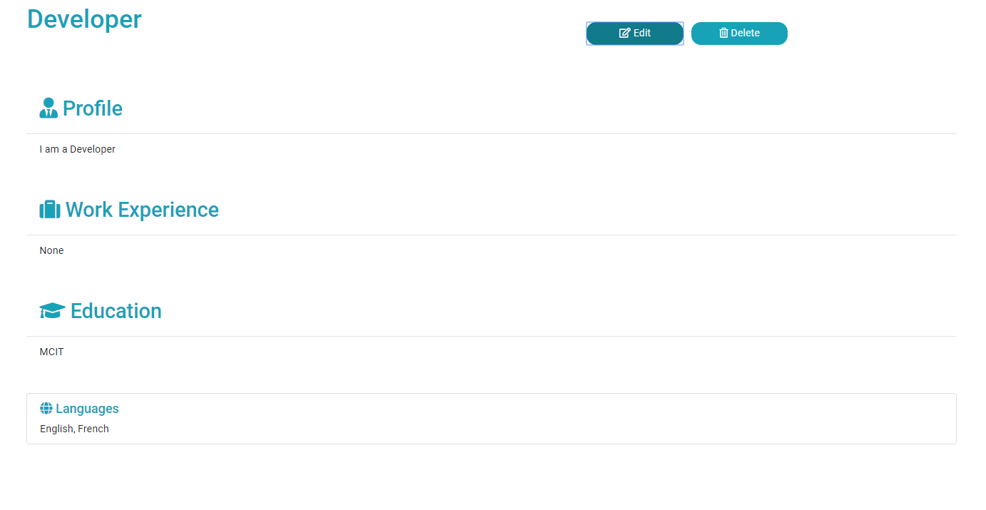

In case you want to delete a selected CV by clicking on the ‘’Delete’’ button, a warning will show up. By simply clicking on the “OK” you will delete the CV or you can cancel and no changes will occurs. BE AWARE this is a FINAL CHANCE to not deleted your CV.

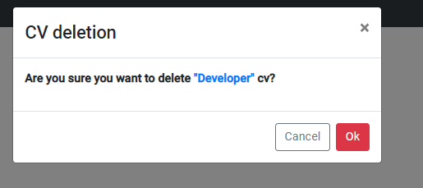

**Jobs Offers** will be another feature available for guest and Candidate as well.

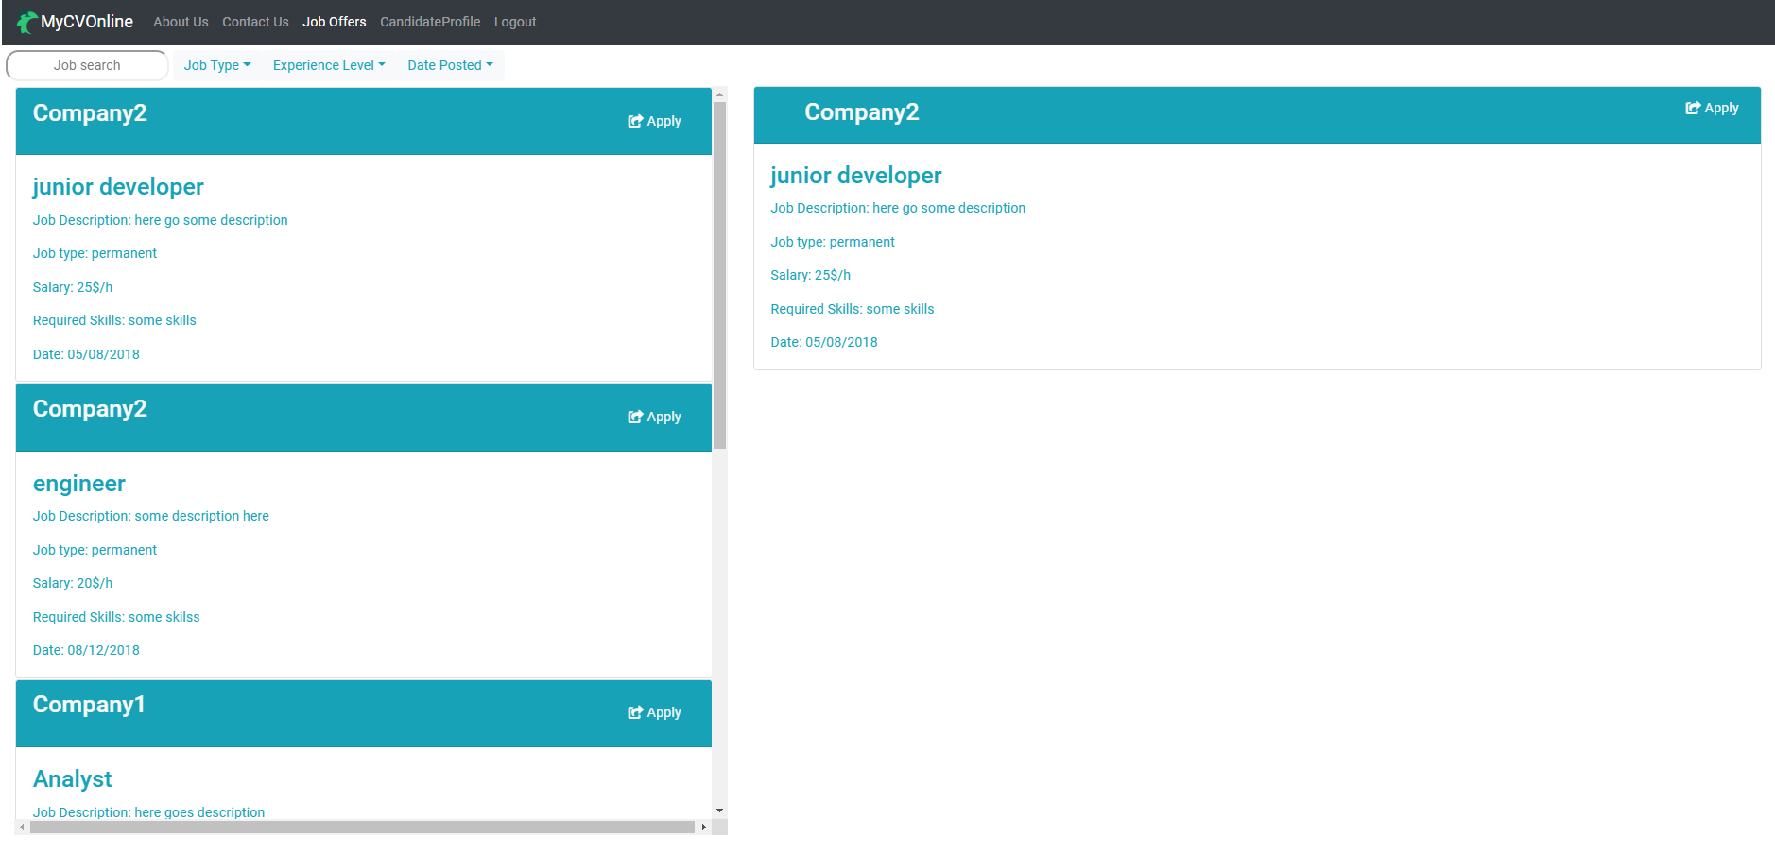

From here you will be able to search for different posted jobs from multiple companies. On the input top right, you will be able to insert an specific job name and it will filter through the list of jobs posted on the data base. (*more filters will come in future updates of the app*).

**Company Profile**

Once that you login as a Company you will be able to navigate through the available options for this type of user.

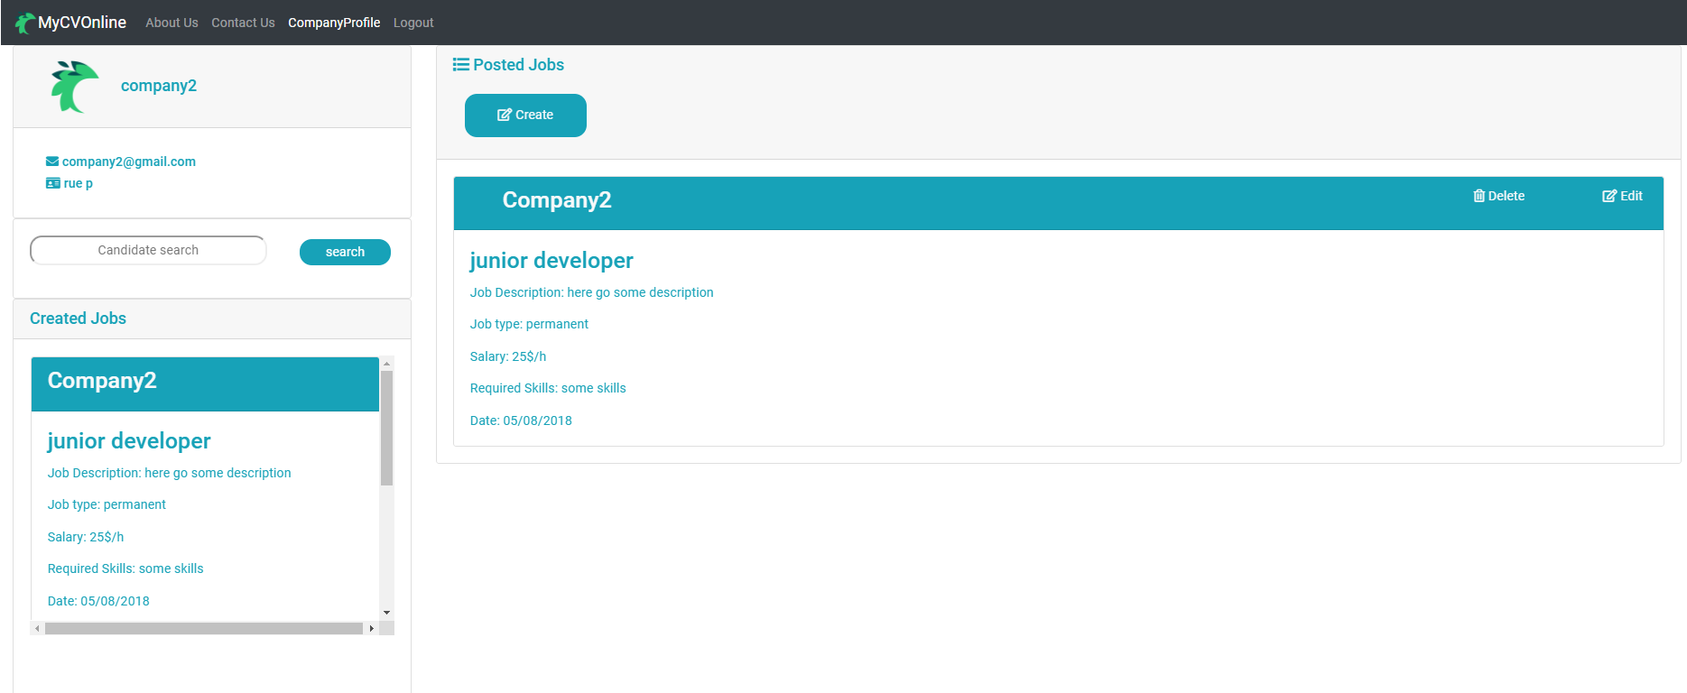

From here you can create, delete of modify Company Jobs Offers. On the left side it will appear your Company name and email address and under it will appear a search that allows you to look up for possible candidates at an specific position (*this feature will come in future updates of the app*).

Below you will find the list of your Company created Jobs. The scroll will help you navigate from one job to another and clicking on each will display a bigger view in the right side of the screen.

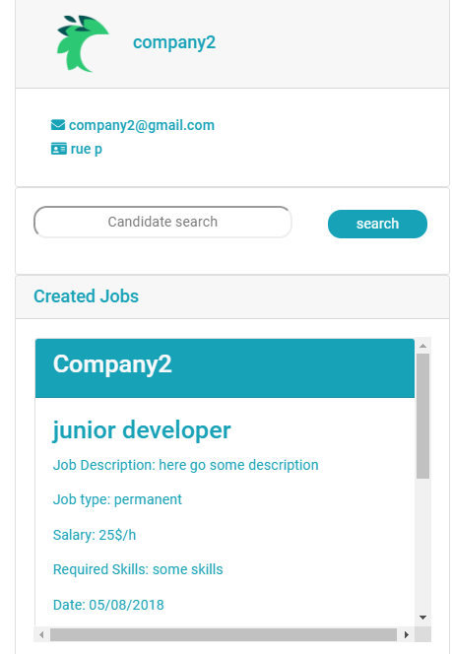

On the right side of the screen, the View component will display multiple options. The Create button from where you will be adding Jobs.

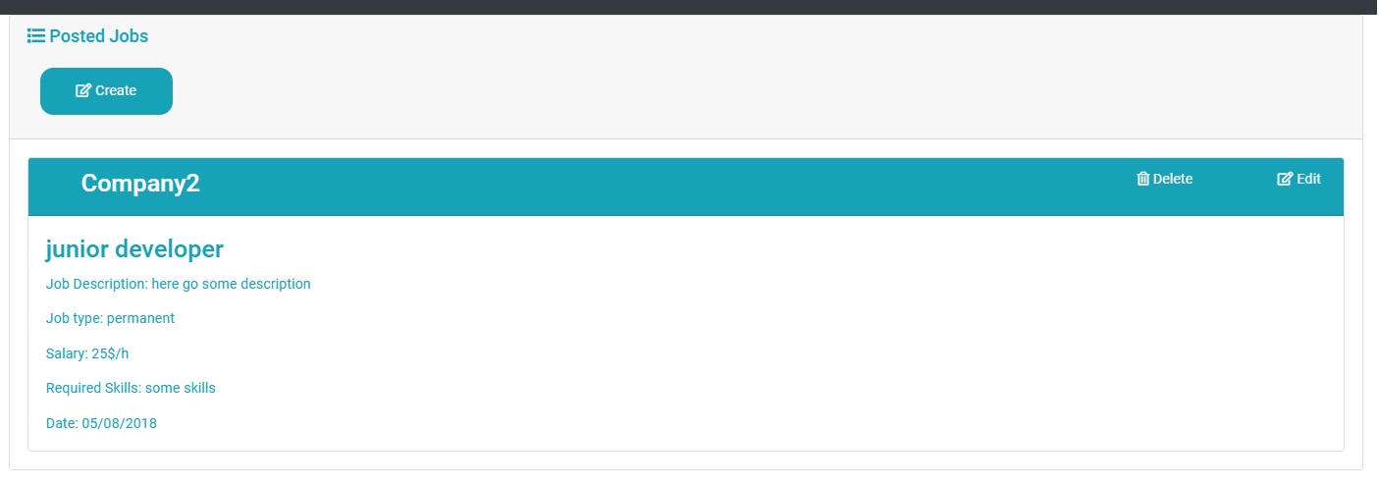

Once you click on the “Create” button a modal will show up and you will be able to enter the information related to this new Job.

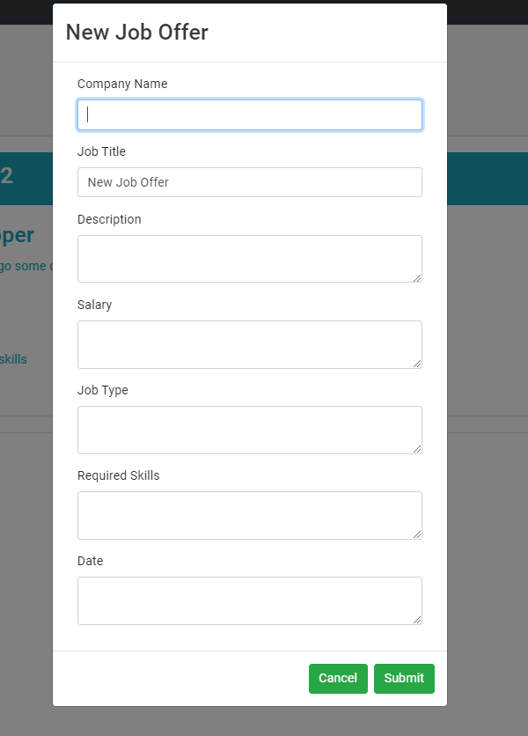

A soon as you feel comfortable with all the information added, you can click on “Submit” and the job will be added to the Created job list, it will be saved in the data base, and Candidates and Guest users of the system will be able to see them.

If you are not sure of creating this New Job Offer, click on cancel and nothing will be added.

Also, after creating a job, the button Edit will re-display the modal from where you will be able to change any information related to the selected job.

And of course, you always have the option of “Delete”, a warning will show up before deleting. By simply clicking on the “Ok” you will delete the Job, or you can cancel and no changes will occurs. BE AWARE this is a FINAL CHANCE to not deleted your Job.

